CHEMICAL BLENDER

A chemical blender, often referred to as a chemical mixer or chemical mixing system, is a piece of equipment used in various industries to blend or mix different chemicals or substances. These systems are designed to ensure uniform mixing of chemicals, which is crucial in various processes, including chemical manufacturing, pharmaceuticals, food processing, water treatment, and more.

The specific design and features of a chemical blender can vary greatly depending on the industry and the chemicals involved.

Components required:

* DC gear motor
* 9V HW battery with cap
* Switch
* Connecting wires
* Handle element

Structure:

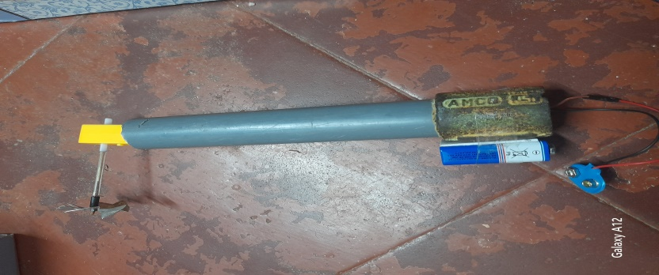

Purpose:

Here are some common purposes of chemical blenders:

Chemical Reactions: In chemical manufacturing, blenders are used to mix reactants to initiate chemical reactions. This can be used to create new compounds or products

Waste Treatment: In environmental applications, blenders are used to mix and treat hazardous waste materials for disposal.

Continuous Mixing: In some industrial processes, blenders are used for continuous or inline mixing, ensuring a constant flow of mixed material.